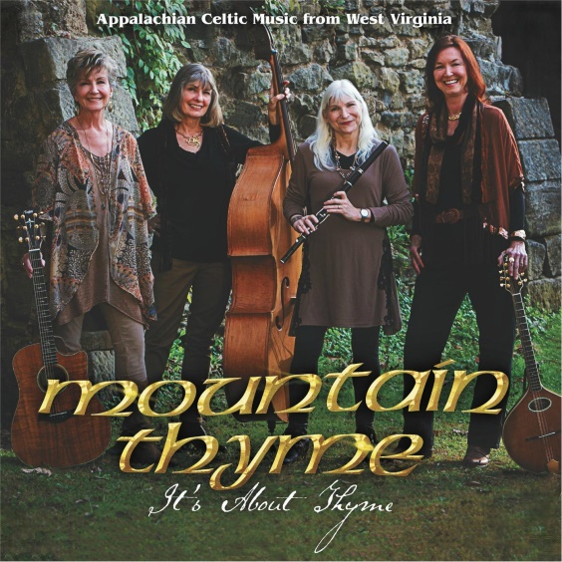

MOUNTAIN THYME

It’s About Thyme
15 Tracks, 51 Minutes
www.mtnthyme.com

A quartet of ladies from an area of the USA rich in its own Celtic rooted traditions. Mountain Thyme are Pam Curry; bouzouki, octave mandolin, autoharp, vocals, Jan Carroll; wooden and silver flutes, penny whistle, vocals, Libby Musser; upright bass, piano, vocals, and Linda Workman; guitar, djembe, vocals. On this recording and for most of their performances they are joined by Cathy Grant on fiddle.
They have been together as a band since 1982 and have shared their music and social lives for over thirty years, and that shows in the empathy between them on this album. They come from the mountainous ridges of West Virginia, home of a distinctive singing style, which is clearly evident in such tracks as Horo Johnny with its close harmony Appalachian singing or the fiddle led Cold Frosty Morning with it regular beat. They have a deep love of Irish and Scottish material too and they choose it generously on this album.
They make a grand job of Paidraigin Ni Uillachain’s Willow Tree. There’s a steady thrum from an autoharp, which carries the song to its conclusion. On the Little Jing we get a dark modal tune on the bouzouki. It’s an original composition from band member Pam Curry, named after a favourite family Labrador. It has an 18th century barbershop whiff about it, the very place in Colonial America to hear the latest cittern number. The flute shines on Peggy and the Soldier which is a version of a song we’d know in Ireland as Mary and the Soldier. Here the girls slow it down a fraction with a chorus that echoes with clear high notes. The flute features again on the Rolling Waves/Bill Harte’s Jig/The Ten Penny Bit. These are taken at a much slower pace than we’d be used to in Ireland, giving the girls space to develop the melodies. Bill Harte’s Jig pays a nod to Bothy Band DNA with a pulsing blast on the bouzouki. The final song Home by Bearna, gave me goose pimples. The lead singer (who isn’t identified in the liner notes), sings “in Scartaglen there lived a lass and every Sunday after mass she’d take a glass before going home by Bearna,” as she summons up the ghost of a young Jean Ritchie.
The girls put a West Virginian stamp on a repertoire they have been sharing for years and that fellowship shines on every number. If you are in any doubt how much fun they had making the album, keep listening to the final track as it segues into a spliced outtake.

Sean Laffey

Irish Music Magazine
March 2017

